Tested by: Stanley Chidi Ohakaba
Date: 02/10/2026
Device/browser: Google chrome browser and Automated Node.js test environment

Feature tested: Basic checkout functionality

Steps performed:

1. Added checkout functionality to the existing cart flow.
2. Tested navigation from a populated cart to `/checkout`.
3. Tested checkout validation with an empty form.
4. Tested invalid delivery and payment details.
5. Tested valid fictional demo payment details.
6. Tested order creation and confirmation flow.

Expected result:

* Users can proceed from a populated cart to checkout.
* Required customer, delivery and payment fields are validated.
* Invalid or incomplete information prevents checkout.
* Valid fictional demo details result in a simulated successful payment and order confirmation.
* No real payment is processed.
* An order ID is generated and the order total is displayed.

Actual result:

* Checkout route and form were implemented successfully.
* Invalid/empty submissions are rejected with validation messages.
* Valid demo checkout data passes validation.
* Order confirmation functionality and order ID generation were implemented.
* Automated checkout tests all passed.

Result: Pass

Evidence:

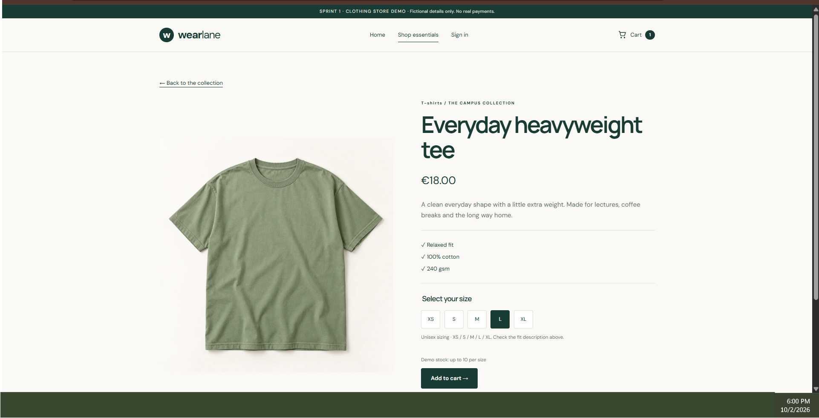
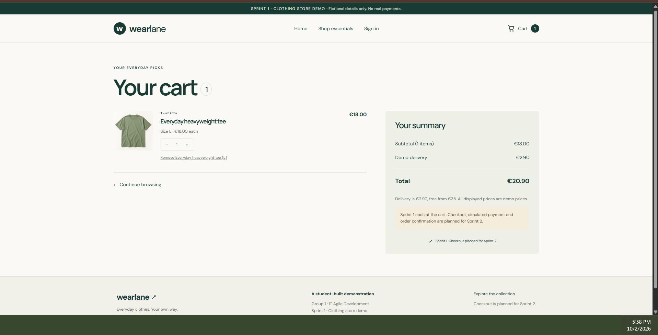

* Automated test suite: `npm test`
* Result: 34 tests passed, 0 failed.
* Checkout evidence file attached separately.

Remaining issues:

* Browser/Vite production build could not be executed because dependency installation timed out and Vite was unavailable in the test environment.
* Manual browser verification should still be performed before moving the Jira task to Done.
* This is a demo checkout; no real payment processing is implemented.

